Performance Testing
Performance and Testing
Define the Problem Statement
Date: 02November2025
NM ID: 8963A6FAA28AB2DAFE341502300DD57E
Project Name: Optimizing-User-Group-and-Role-Management-with-Access-Control-andWorkflows
Maximum Marks: 4Marks
- Create User
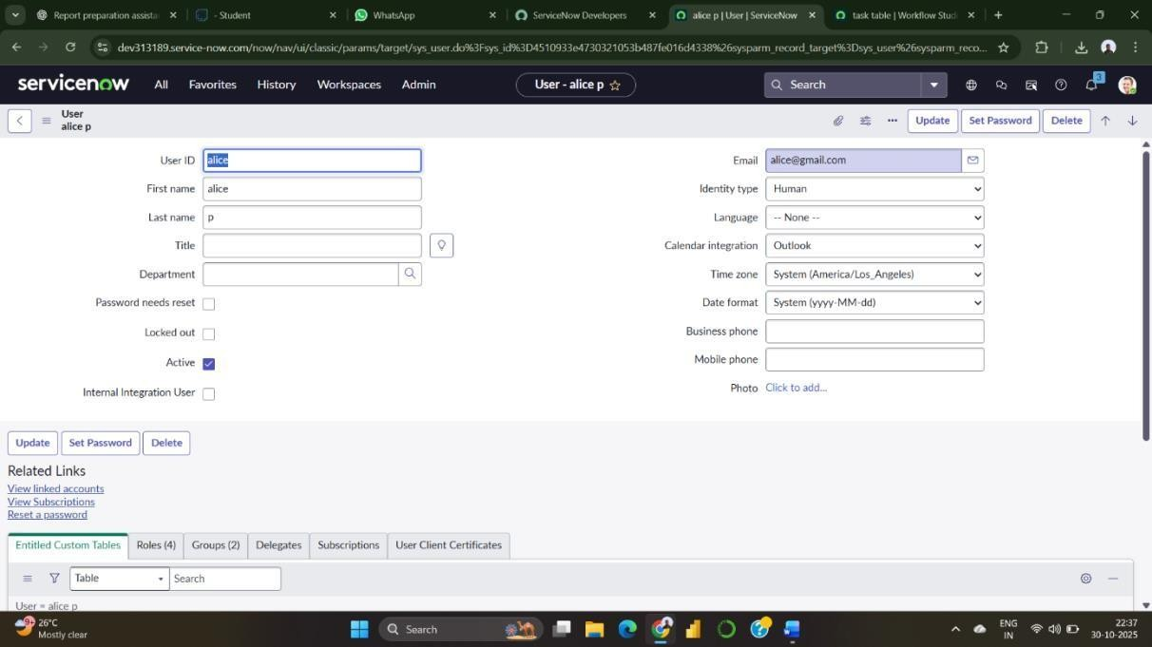
- Create Groups
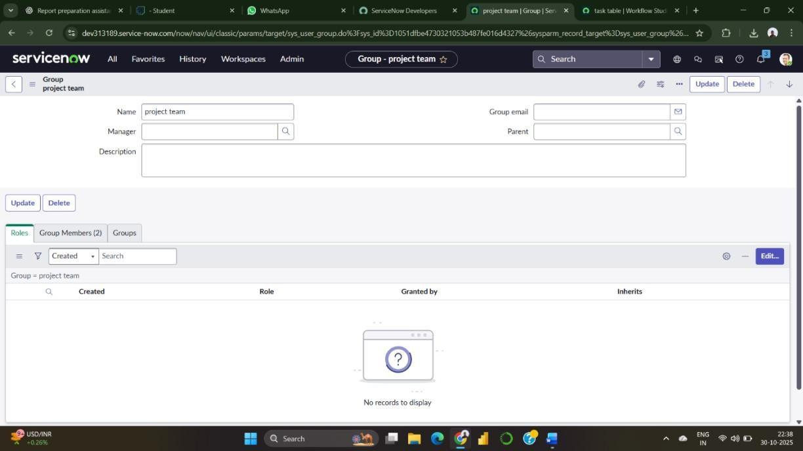
- Create Role
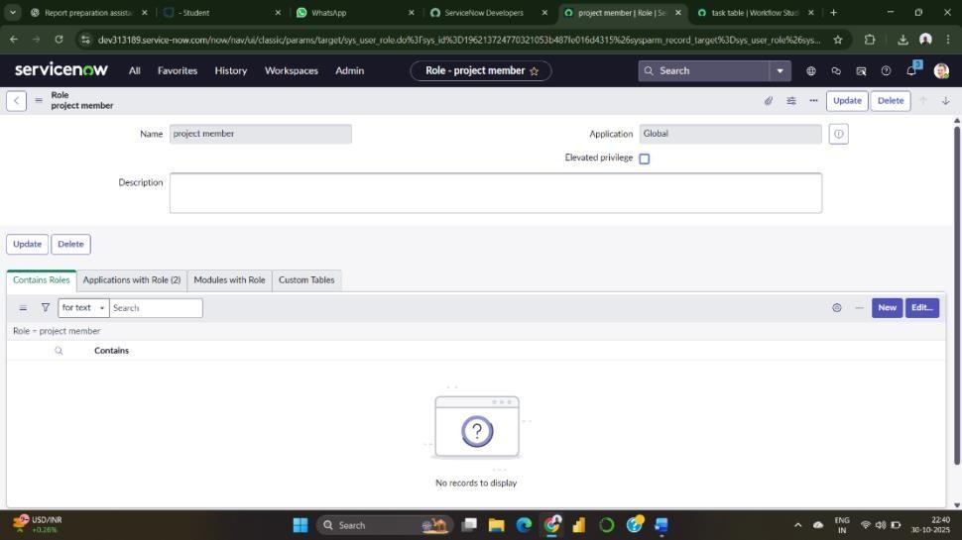
- Create a Table and Assign the operations
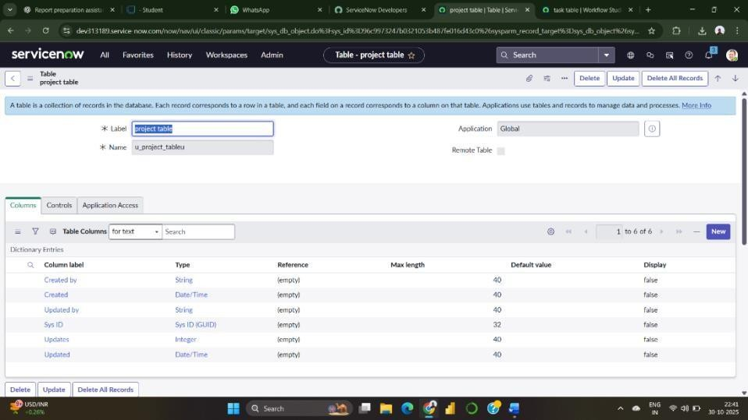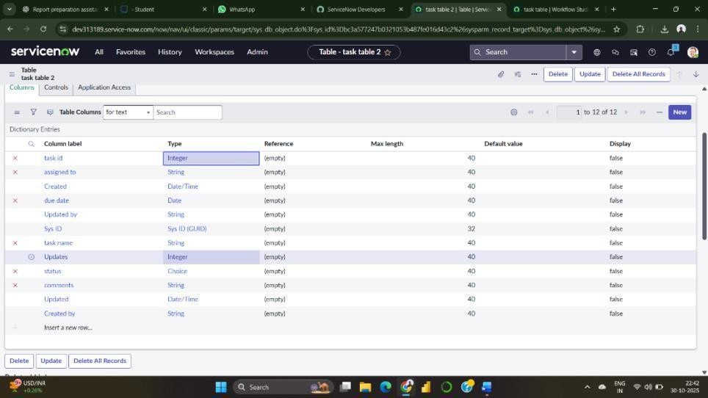
- Assign Roles
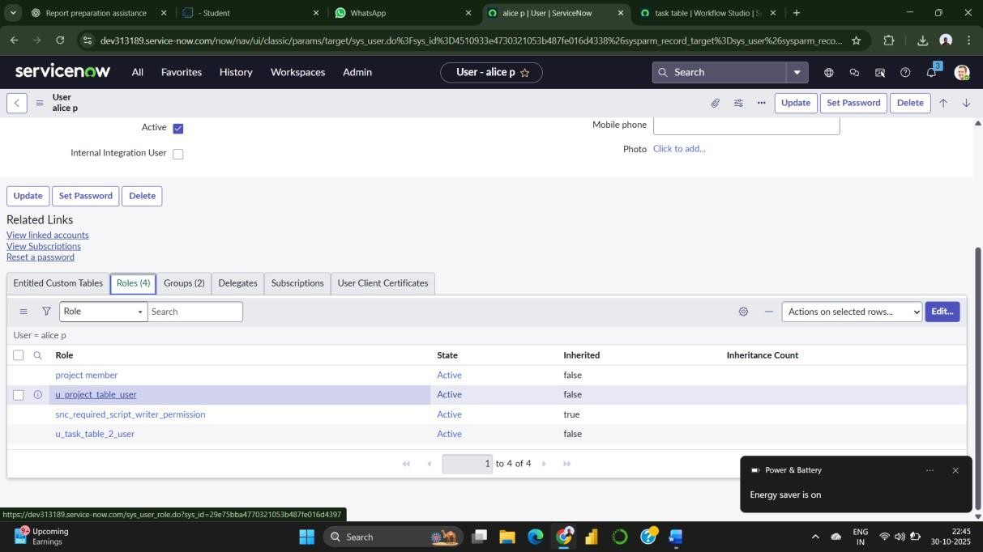
- Assign Table Access to Applications
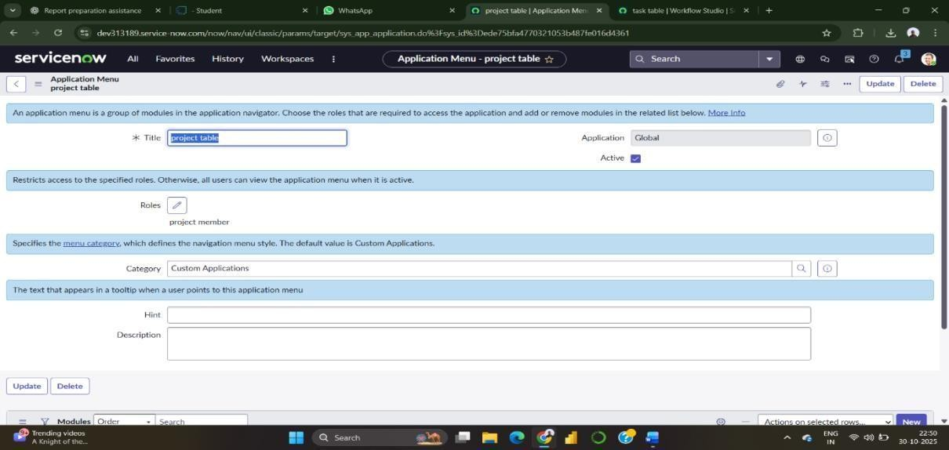
- Assign Access Control
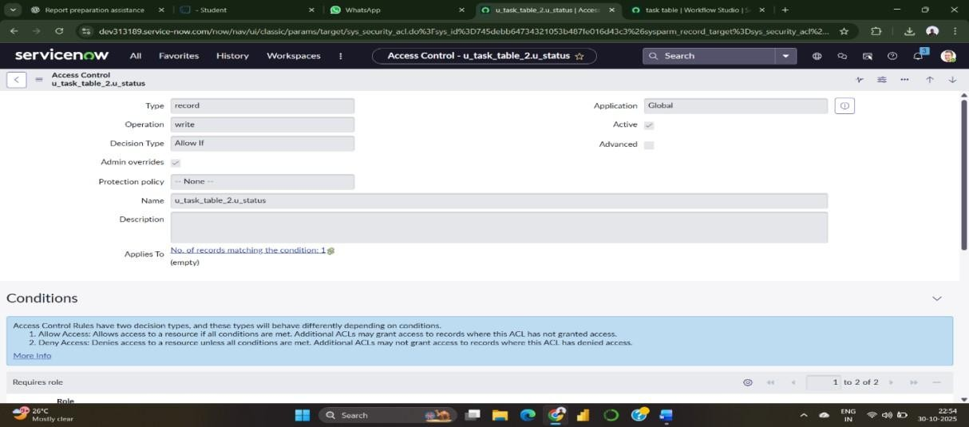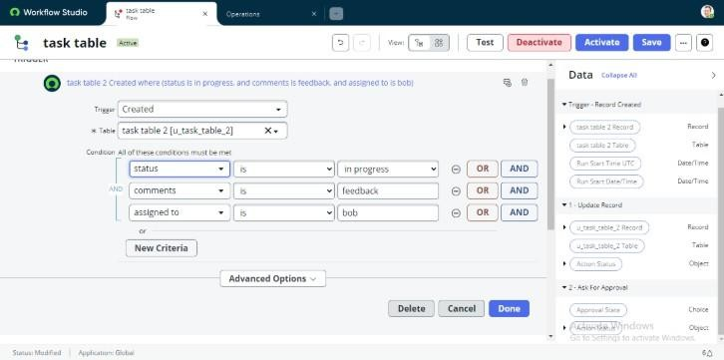
- Create Flow

